**DATABASE Design**

1. **Banks**

|  |
| --- |
| Banks |
| UID  UName  Utype  BAL_AMT |

1. **Transhis**

|  |
| --- |
| transhis |
| UID  TID  TAMT  TSTATUS  TDATE |

**Architecture diagram**

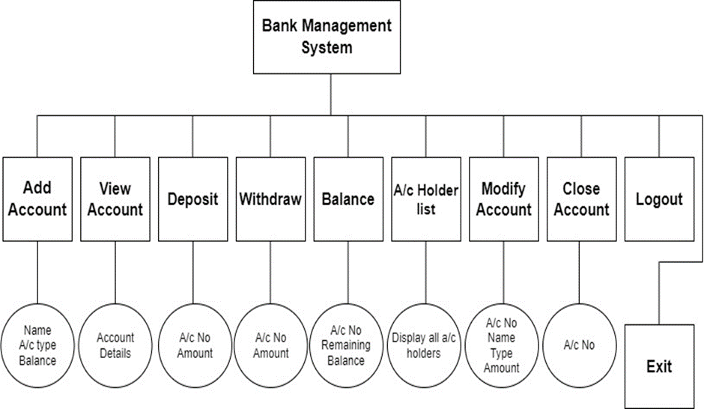

**UML Diagram**

1. **Class Diagram**

**Transhis**

**Banks**

**tid:integer**

**tamt:integer**

**tstatus:string**

**tdate:date**

**uid:integer**

**uname:string**

**utype:char**

**bal_amt: int**

**aat**

**1 1**

**deposit()**

**withdraw()**

**modify()**

**add_account()**

**view()**

**deposit()**

**withdraw()**

**modify()**

**Use Case Diagram**

